

Supporting Information for

Observations of super plasma bubbles over South East Asia longitude sector

Chunhua Jiang1*, Lehui Wei, Guobin Yang1, Ting Lan1, Tongxin Liu1, Jing Liu2, Zhengyu Zhao1

1School of Electronic Information, Wuhan University, 430072, Wuhan, Hubei, China.

2Institute of Earthquake Science, China Earthquake Administration, Beijing, China.

Corresponding author:

Chunhua Jiang. Email: [chuajiang@whu.edu.cn](mailto:chuajiang@whu.edu.cn)

**Contents of this file**

Tables S1 to S2, Figure S1-S3.

**Additional Supporting Information (Files uploaded separately)**

**data.zip**

The files of Puer.zip, Leshan.zip and Zhangye.zip include ionograms (*.amp), the corresponding ionospheric parameters (*.para). They are available at the following repository: https://github.com/chuajiang/publish_data.

**Introduction**

This supporting information introduces the ionograms data used in this study. The ionograms data used in this study are available at the following repository: https://github.com/chuajiang/publish_data.

The files of *.amp and *.para in zip files are corresponding to ionograms data and ionospheric parameters from ionogarms, respectively.

The file formats of *.amp and *.para were shown in Table S1-S2, readers could read them instructed by Tables S1-S2.

Figures S1-S3 represent a series of ionogram with spread F recorded at Zhangye (39.4oN, 100.13oE, 29.59oN magnetic latitude), Leshan (29.6oN, 104oE, 19.76oN magnetic latitude) and Puer (22.7oN, 101.05oE, 12.9oN magnetic latitude) stations at the beginning, respectively after the increasing altitude of the ionosphere (12:00 UT, LT=UT+7) on 8 September, 2017.

Table S1.File format of *.amp recorded by ionosonde

|  |  |  |  |  |
| --- | --- | --- | --- | --- |
| Bytes | Description | Unit | Range | Type |
| 1-4 | Start frequency | MHz | 0-20 | float |
| 5-8 | Step frequency | KHz | 0-1000 | float |
| 9-12 | Stop frequency | MHz | 0-20 | float |
| 13-16 | Sounding times of each frequency | time | 1-128 | float |
| 17-20 | Total Range number of echoes | one | 1-700 | float |
| 21-24 | Range resolution | km | 3.84, 3.84*n,n=1,2.. | float |
| 25-28 | Number of frequency | one | 1-1000 | float |
| 29-32 | Echo starting position | one | 1-20 | float |
| 33-36 | Type of sounding code | - | 1:complementary code; otherwise: m sequence | float |
| 37-40 | Code order | one | 1-20 | float |
| 41-44 | Pulse width | one | 1-20 | float |
| 45-48 | Pulse repetition period | second | 1-1000 | float |
| 49-52 | Start year | year | 0-2999 | float |
| 53-56 | Start month | month | 1-12 | float |
| 57-60 | Start day | day | 1-31 | float |
| 61-64 | Start hour | hour | 0-24 | float |
| 65-68 | Start minute | minute | 0-59 | float |
| 69-72 | Start second | second | 0-59 | float |
| 73-76 | Stop year | year | 0-2999 | float |
| 77-80 | Stop month | month | 1-12 | float |
| 81-84 | Stop day | day | 1-31 | float |
| 85-88 | Stop hour | hour | 0-24 | float |
| 89-92 | Stop minute | minute | 0-59 | float |
| 93-96 | Stop second | second | 0-59 | float |
| 97-100 | Latitude of station | degree | 0-90 | float |
| 101-104 | Latitude of station | minute | 0-59 | float |
| 105-108 | Latitude of station | second | 0-59 | float |
| 109-112 | North and south latitude | - | 0:north; 1:south | float |
| 113-116 | Longitude of station | degree | 0-180 | float |
| 117-120 | Longitude of station | minute | 0-59 | float |
| 121-124 | Longitude of station | second | 0-59 | float |
| 125-128 | East and west longitude | - | 0: east; 1: west. | float |
| 129-132 | Code width | one | 1-100 | float |
| 133-136 | Mode of sounding | - | 0: sweep frequency sounding; 1: fixed frequency sounding; 2: hop frequency sounding. | float |
| 137-140 | Display Range number of echoes | one | 1-700, indicates number of echoes to be displayed on ionogram. | float |
| 141-144 | Type of sounding | - | 0: vertical sounding; 1: backscatter sounding; 2: oblique sounding. | float |
| 145-500*4 | Reserved | - | - | - |
| 500*4+1-end | data | - | - | float |

Table S2.File format of *.para

|  |  |  |  |
| --- | --- | --- | --- |
| Line number | format | description | example |
| 1 | xxxxx | Name of ionosonde | Wuhan Ionospheric Sounding System |
| 2 | xxx1.xx2.xx3 xxx4.xx5.xx6 | Location of station, such as: “degree.minute.second degree.minute.second”, the first is longitude, the second is latitude. | 101.58.0 22.44.30 |
| 3 | xxx1 xxx2 | Name and version of this software, xxx1: name; xxx2: number of version. | ionoScaler v1.0 |
| 4 | FF YMD_HMS | Sounding date and time. FF: an identifier. | FF 20131118_041500 |
| 5 | PP fxI foF2 foF1 foE ftEs h’F2 h’F1 h’E h’Es hmF2 hmF1 hmE hbF2 hbF1 hbE ITEC | PP: an identifier. | PP 4.3500 4.0000 0.0000 0.4825 0.0000 188.2777 0.0000 0.0000 0.0000 239.0512 0.0000 130.0000 159.0512 0.0000 90.0000 3.3606 |
| 6…N | VV xx1 xx2 xx3 xx4 xx5… xxn | Synthesized trace, VV: an identifier; xx1: starting frequency (MHz); xx2: step frequency (KHz); xx3: total number of sounding frequency; xx4: virtual height of the first sounding frequency (km); xx5: virtual height of the second sounding frequency (km); and so on. | VV 2.0000 50.0000 39.0000 188.2777 189.4576 ….. |
| N+1…M | TT xx1 xx2 xx3… xxn | Electron density profile, TT: an identifier; xx1: start height of the profile (km); xx2: step height of the profile (km); xx3: total number of height points; xx4: frequency of the first height (MHz); xx5: frequency of the second height (MHz); and so on; | TT 90.0000 0.1000 1491.0000 0.0001 0.0342 0.0484 … |

Figures

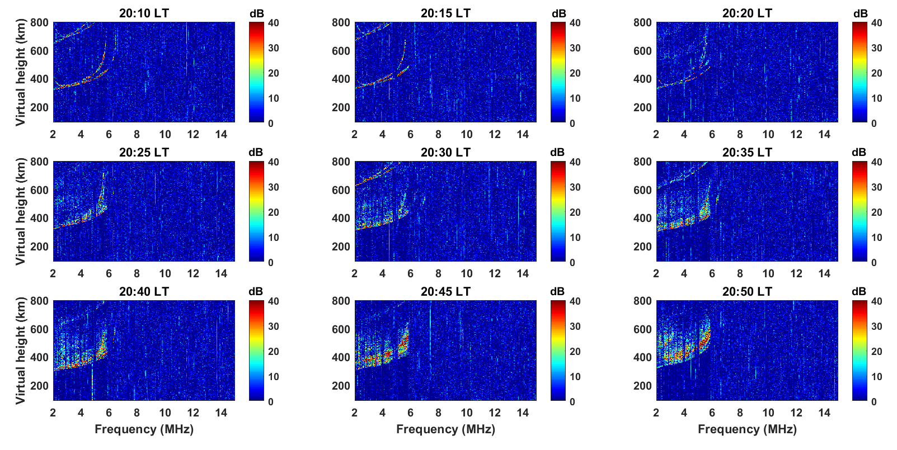

Figure S1. Ionograms with spread F recorded at Zhangye station at the beginning after the increasing altitude of the ionosphere (12:00 UT, LT=UT+7) on 8 September.

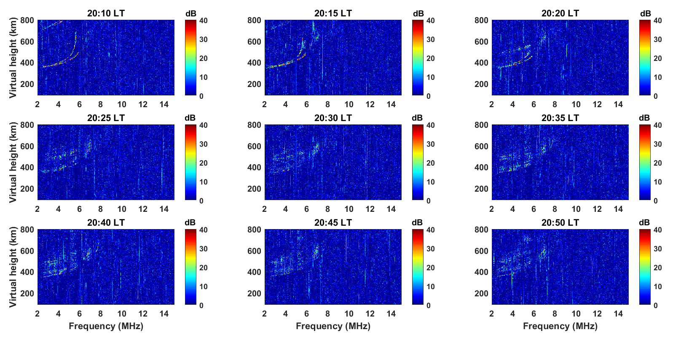

Figure S2. Ionograms with spread F recorded at Leshan station at the beginning after the increasing altitude of the ionosphere (12:00 UT, LT=UT+7) on 8 September.

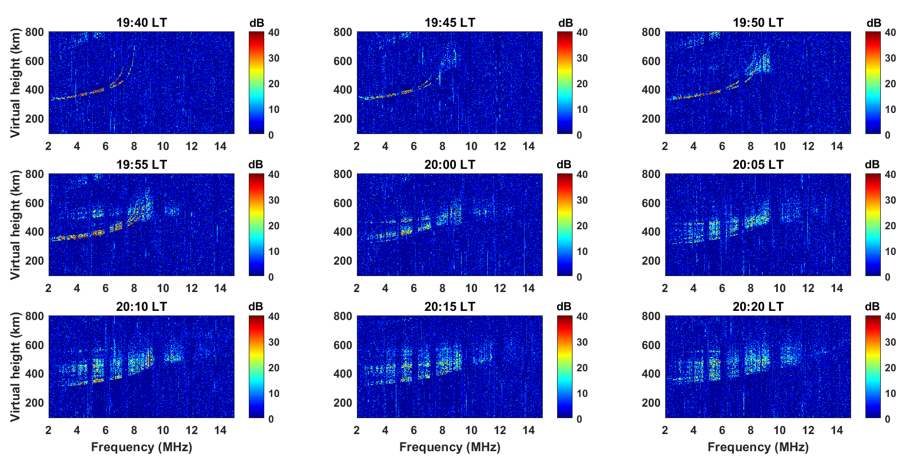

Figure S3. Ionograms with spread F recorded at Puer station at the beginning after the increasing altitude of the ionosphere (12:00 UT, LT=UT+7) on 8 September.